|  |  |  |
| --- | --- | --- |
| American University of SharjahCollege of Engineering Department of Computer Science & Engineering  P. O. Box 26666  Sharjah, UAE |  | **Lab Instructor:** Eng. Sameer Alawnah  **Office:** EB2-101  **Phone**: 971-6-5152974  **e-mail**: salawnah@aus.edu  **Semester**: Fall 16 |

**CMP 220L – Introduction to Computer Science II**

**Lab 2**

**Note: The good programmer adds comments to his/her code. Add comments to your code.**

**Question 1:**

Write a program that does the following:

Reads two integer values (num1 and num2) and a character symbol (*, -, +, /, or %) from *inputs.txt.*

Calculates results based on the character read and writes these results to the output file *result.txt* as demonstrated in the following example.

*Sample output:*

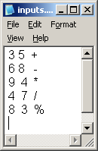 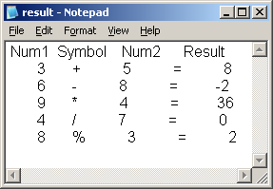

#include <iostream>

#include <fstream>

using namespace std;

void main()

{

ifstream input;//initiating the input file

ofstream output;//initiating the output file

input.open("inputs.txt");//open input.txt

output.open("results.txt");//open results.txt

int num1, num2, res;//initiating integers

char sym;//initriating characters

output << "Num1" << " " << "Symbol" << " " << "Num2" << " " << "Result" << endl;//print headers

input >> num1;//input first numbers

input >> num2;//input second number

input >> sym;//input symbol character

while (!input.eof())//use while loop to calculate results, until it reaches end of file (eof)!

{

if (sym == '+')

{

res = num1 + num2;

}

else if (sym == '-')

{

res = num1 - num2;

}

else if (sym == '*')

{

res = num1*num2;

}

else if (sym == '/')

{

res = num1 / num2;

}

else if (sym == '%')

{

res = num1%num2;

}

output << num1 << " " << sym << " " << num2 << " = " << res << endl;

input >> num1;

input >> num2;

input >> sym;

}

input.close();//close input

output.close();//close output

}

//THE END :D!

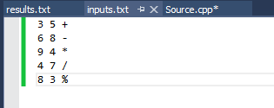

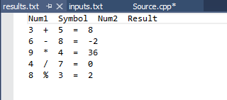

**Question 2:**

Write functions with the following headers:

int* readVector(char fname[],int &size)

This function should read values from the file and save them in a 1D array (vector) and return a pointer to it.

The first element in the file is number of values followed by the values. Note that size is passed to the function by reference, so you have to define it in the caller.

void printVector(char fname[],int *M,int size)

This function should print the content of the 1D array to the output filet.

void VectorAdd (int *A, int *B,int *R, int size)

The function perform a scalar addition the vector $A_{size}$ with the vector $B_{size}$ and save the result in vector $R_{size}$. ( element by element multiplication).

Test the function with a program that reads two files “input1.txt” and “input2.txt” and save the results in pointers A and B, call the VectorAdd to calculate the vector R then finally print the result in the file “output.txt”.

#include <iostream>

#include <fstream>

using namespace std;

int* readvector(char fname[], int &size);

void printvector(char fname[], int *M, int size);

void vectoradd(int* A, int* B, int* R, int size);

void main()

{

int size;

int *ptr1, *ptr2, *res;

ptr1 = readvector("input1.txt", size);

ptr2 = readvector("input2.txt", size);

res = new int[size];

vectoradd(ptr1, ptr2, res, size);

printvector("output.txt", res, size);

}

int* readvector(char fname[], int &size)

{

ifstream input;

input.open(fname);

input >> size;

int *ptr = new int[size];

for (int i = 0; i < size; i++)

{

input >> ptr[i];

}

return ptr;

input.close();

}

void vectoradd(int* A, int* B, int* R, int size)

{

for (int i = 0; i < size; i++)

{

R[i] = A[i] + B[i];

}

}

void printvector(char fname[], int *M, int size)

{

ofstream output;

output.open(fname);

for (int i = 0; i < size; i++)

{

output << M[i] << endl;

}

output.close();

}

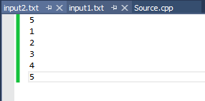

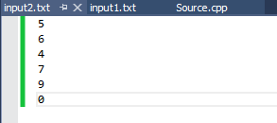

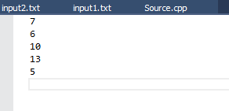

**Question 3:**

Do the following tasks in order (you can only use C++ strings functions):

1. Create a C++ string (str1) and initialize it to “I am lovin c++, I am so smart :p”.
2. Print str1 and its length.
3. Create another C++ string (str2) and initialize it with user input.
4. Concatenate str1 and str2 into a third string (str3).
5. Print str3 and its length
6. Clear str3 and print it to make sure its empty.
7. Copy the letters between indices 6 and 12 of str1 to str3.
8. Print str3.

#include <iostream>

#include<string>

using namespace std;

void main()

{

string str1;

str1 = "I am lovin C++, I am so smart :p " ;

cout << str1 << endl;

cout << "Length = " << str1.length() << endl;

string str2;

cout << "please enter the second string: ";

getline(cin,str2);

string str3;

str3 = str1 + str2;

cout << str3 << endl;

cout << "Length = " << str3.length() << endl;

str3.clear();

cout << "str3 after its cleared = " << str3 << endl;

str3 = str1.substr(6, 12);

cout << "str3 = " << str3 << endl;

}

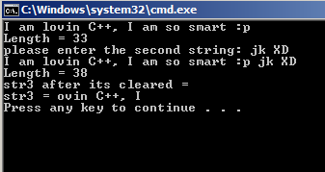**if**

**Question 4:**

Write a program that reads the content of a file word by word and save it to an output file replacing the word “CMP” with “COE”. Your program should also print to the user (console) the number of times the following words appeared in the input file (is, was, he and she). Note: you have to use C++ strings not C-strings.

Good Luck ☺

#include <iostream>

#include<string>

#include<fstream>

using namespace std;

void main()

{

ifstream input;

ofstream output;

int a =0, b=0, c=0, d=0;

input.open("input.txt");

output.open("output.txt");

string str;

while (!input.eof())

{

input >> str;

if (str == "CMP")

{

str = "COE";

}

if (str == "is") a++;

if (str == "was") b++;

if (str == "he") c++;

if (str == "she") d++;

output << str<<" ";

}

cout << "# of times is appeared = " << a << endl;

cout << "# of times was appeared = " << b << endl;

cout << "# of times he appeared = " << c << endl;

cout << "# of times she appeared = " << d << endl;

input.close();

output.close();

}

